The structure of atoms - Worksheet

- The six sentences below describe simple atomic structure and other types of particles you have already studied. Your task is to match the halves and rewrite them correctly.

 | First half of sentence | Second half of sentence
(a) | Atoms are the smallest particles | only one type of atom.
(b) | Atoms are composed of positively charged protons and neutral neutrons | when different types of atoms bond together.
(c) | Elements contain | formed when two or more atoms bond together.
(d) | Molecules are | of matter that can take part in a chemical reaction.
(e) | Compounds form | known as monatomic molecules.
(f) | Atoms of an element are also | contained in a central nucleus with negatively charged electrons in orbits around the nucleus.

 | Complete sentences
(a) | Atoms are the smallest particles
(b) | Atoms are composed of positively charged protons and neutral neutrons
(c) | Elements contain
(d) | Molecules are
(e) | Compounds form
(f) | Atoms of an element are also
- Complete the table to summarise the properties of the particles that make up atoms.

Particle | Where found | Charge
 | in nucleus
Neutron
 |  | Negative

- Compare (state the similarities and the differences between) atoms and molecules.

__________________________________________________________________________

Compare elements and compounds.

__________________________________________________________________________

- Classify each particle of matter represented by the symbols below. You must identify it with two terms.
One word showing if it is an atom or a molecule, and the second showing if it is an element or a compound.
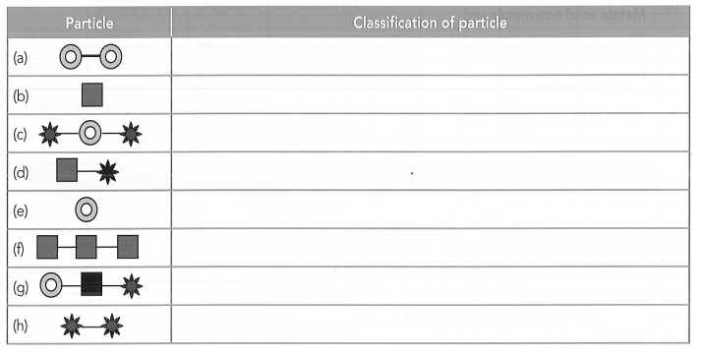
Atom or molecule AND Element or compound

(g) H₂O (water)
(h) C₆H₁₂O₆ (glucose)
(i) NH₃ (Ammonia)
(j) Cu (copper)
(k) NaCl (table salt)

- The seven sentences below describe some of the properties of atoms. Your task is to match the halves and rewrite them correctly.

 | First half of sentence | Second half of sentence
(a) | Atoms of different elements contain | equal to the number of protons in its nuclei.
(b) | The number of protons in the | their increasing atomic numbers.
(c) | Neutral atoms have the same number of | different numbers of protons
(d) | The atomic number, (Z) of an element is | its position on the periodic table of the elements.
(e) | The mass number, (A), of an element is equal to the sum | nucleus determines which element the atom is.
(f) | The atomic number of an element determines | electrons in orbit as protons in the nucleus.
(g) | The modern periodic table is a list of the elements in order of | of the number of protons and neutrons in the nucleus of its atoms.

 | Complete sentences
(a) | Atoms of different elements contain
(b) | The number of protons in the
(c) | Atoms have the same number of
(d) | The atomic number, (Z) of an element is
(e) | The mass number, (A) of an element is equal to the sum
(f) | The atomic number of an element is also
(g) | The modern periodic table is a list of the elements in order of

- Complete the labels on the key and the diagram of an atom of an element below:

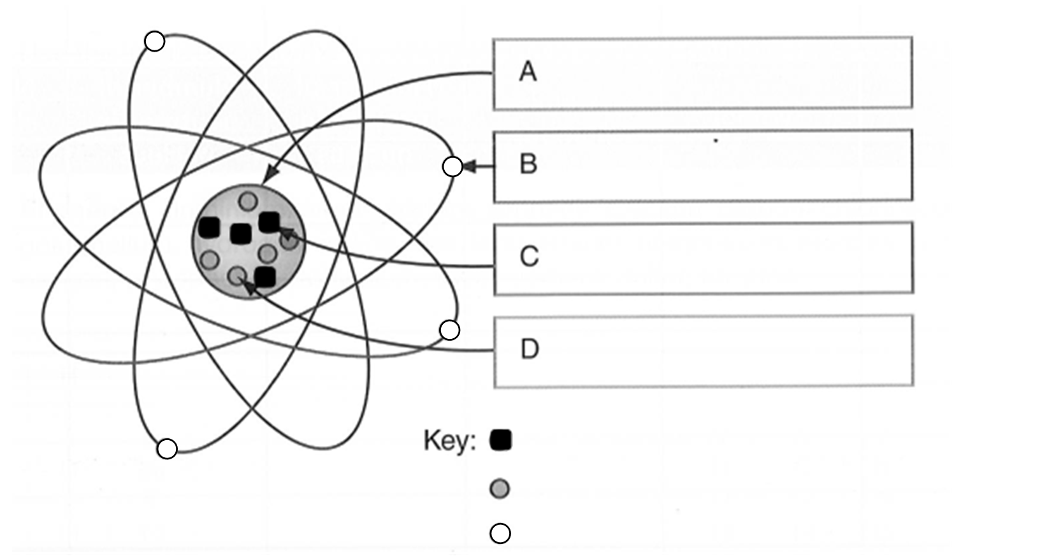

Identify the name of the element represented by this diagram and its symbol.

____________________________________________________________________

- The diagram below shows an element on the periodic table. Identify the labels.

